**STARAGILE TERRAFORM ASSIGNMENT -1**

**Step 1: Download and install Terraform**

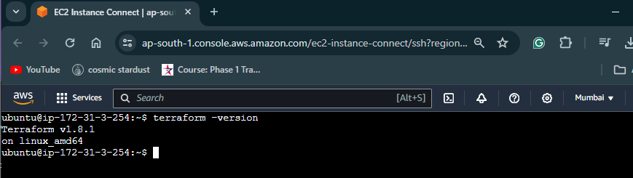

**Step 2: Install AWS CLI**

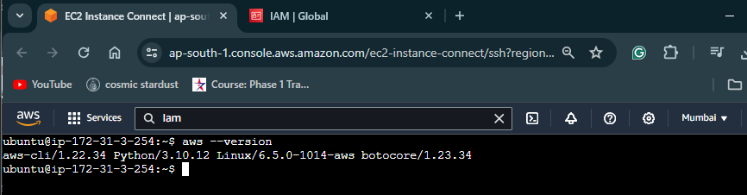

**Step 3: Create IAM User and Obtain Access Keys**

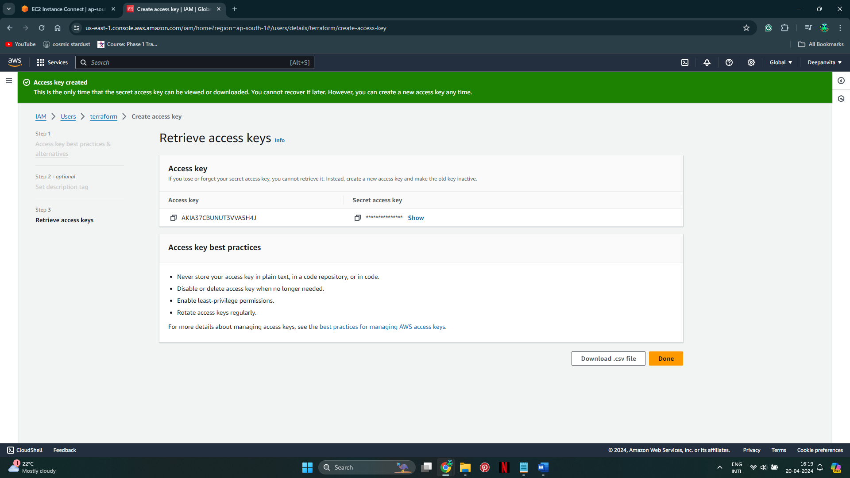

**Step 4: Configure AWS CLI**

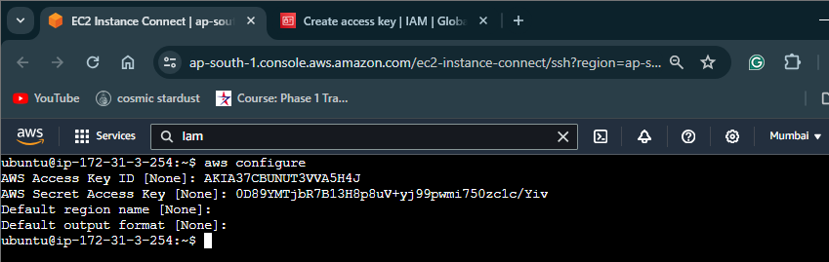

**Step 5: Write Terraform Configuration File (.tf)**

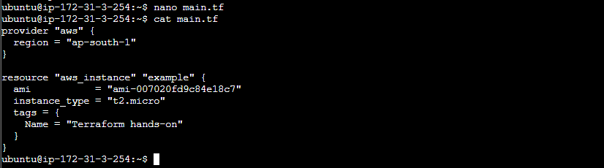

**Step 6: Initialize Terraform**

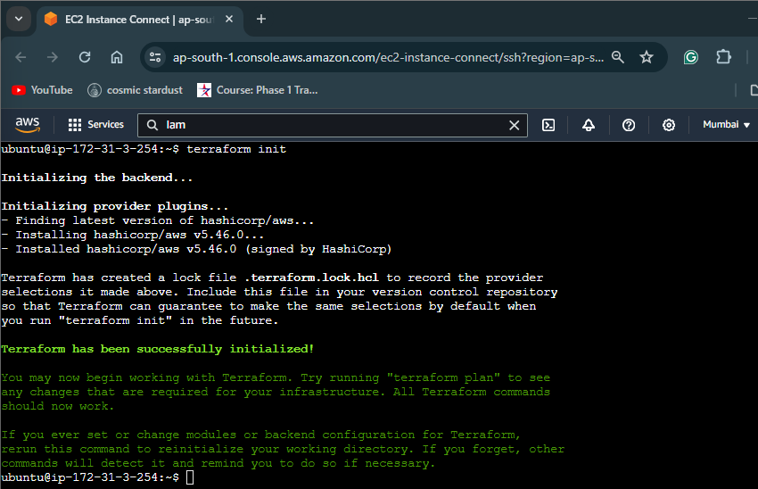

**Step 7: Apply Terraform Configuration**

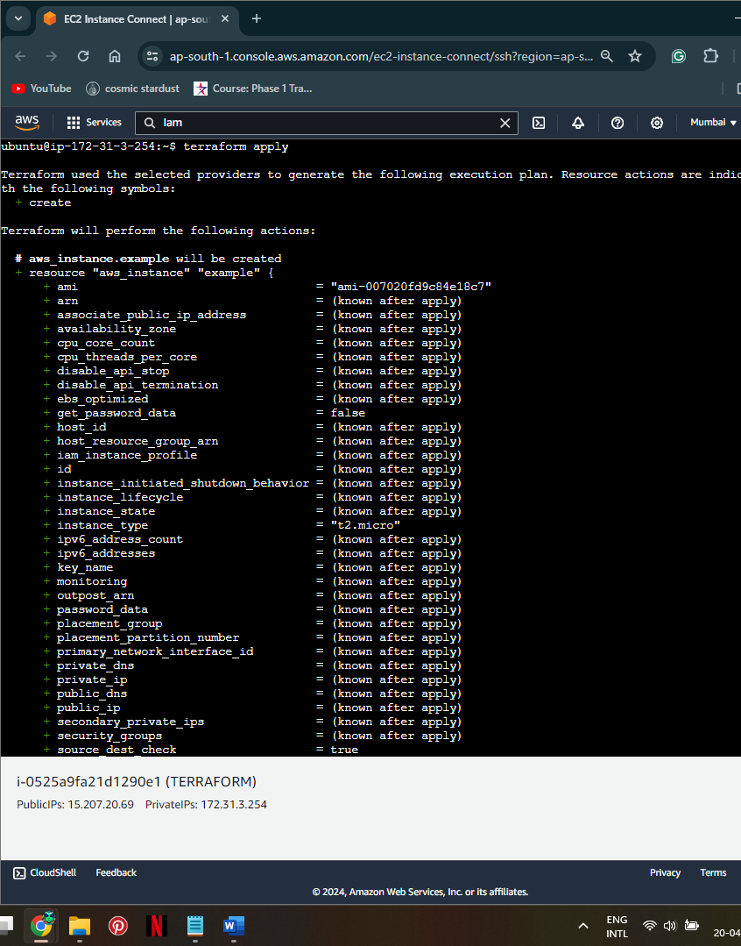

**Step 8: Verify Provisioning**

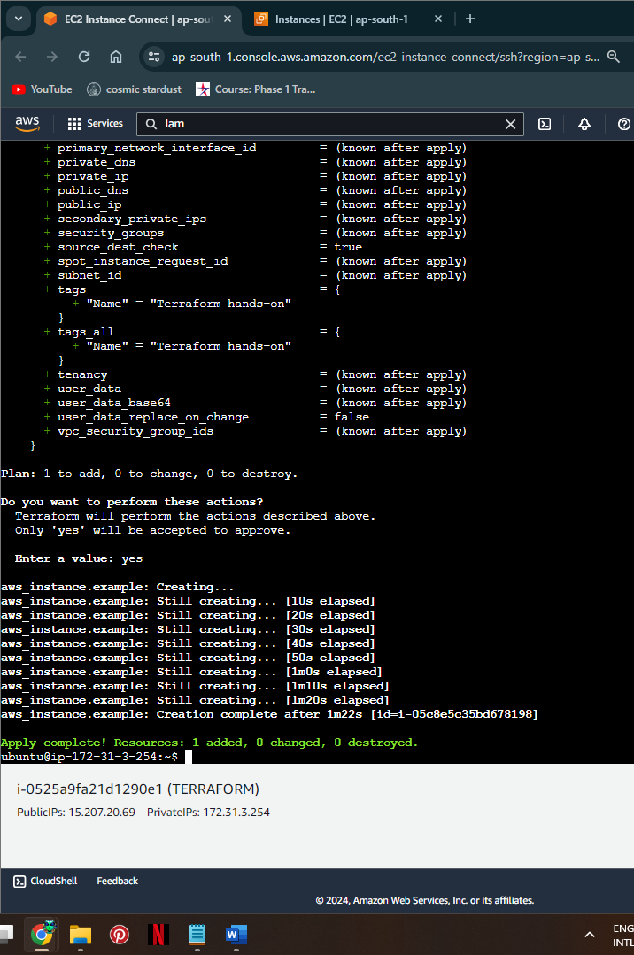

**Step 9. Verify on EC2 instances page**

